Project Synopsis

on

KRISHAK

Submitted as a part of course curriculum for

# Bachelor of Technology

in

# Computer Science



### Submitted by

Kushagra Singh (2100290120099)

Nancy Srivastava (2100290120109)

Tushtee Singh (2100290120176)

Surabhi Agnihotri (2100290120169)

### Under the Supervision of

**Dr. Harsh Khatter**

Assistant Professor

CS Department

# KIET Group of Institutions, Ghaziabad Department of Computer Science

**Dr. A.P.J Abdul Kalam Technical University**

**2023-2024**

# DECLARATION

We hereby declare that this submission is our work and that, to the best of our knowledge and belief, it contains no material previously published or written by another person or material which to a substantial extent has been accepted for the award of any other degree or diploma of the university or other institute of higher learning, except where due acknowledgement has been made in the text.

Signature of Students

Name:

Roll No.:

Date:

Name:

Roll No.:

Date:

Name:

Roll No.:

Date:

Name:

Roll No.:

Date:

# CERTIFICATE

This is to certify that Project Report entitled “**Krishak**” which is submitted by **Kushagra Singh,** **Nancy Srivastava, Tushtee Singh and Surabhi Agnihotri** in partial fulfilment of the requirement for the award of degree B.Tech. in Department of Computer Science of Dr A.P.J. Abdul Kalam Technical University, Lucknow is a record of the candidates own work carried out by them under my supervision. The matter embodied in this report is original and has not been submitted for the award of any other degree.

**Date: Supervision or Signature**

Dr. Harsh Khatter

Assistant Professor

CS Department

# ACKNOWLEDGEMENT

It gives us a great sense of pleasure to present the synopsis of the B.Tech. Major Project undertaken during B.Tech. Third Year. We owe a special debt of gratitude **to Prof. Harsh Khatter**, Department of Computer Science, KIET Group of Institutions, Delhi-NCR, Ghaziabad, for his constant support and guidance throughout the course of our work. His sincerity, thoroughness and perseverance have been a constant source of inspiration for us. It is only his cognizant efforts that our endeavors have seen the light of the day.

We also take the opportunity to acknowledge the contribution of Dr. Ajay Kumar Srivastav sir, Head of the Department of Computer Science, KIET Group of Institutions, Delhi-NCR, Ghaziabad, for his full support and assistance during the development of the project. We also do not like to miss the opportunity to acknowledge the contribution of all the faculty members of the department for their kind assistance and cooperation during the development of our project.

Last but not the least, we acknowledge our friends for their contribution to the completion of the project.

Signature:Date: Name: Roll No:

# ABSTRACT

Krishak is an affordable farm equipment sharing platform aims to revolutionize access to agricultural machinery for small-scale farmers. By leveraging digital technology, the platform connects farmers with surplus equipment to those in need, reducing financial barriers and promoting resource efficiency. Features such as detailed equipment listings, secure booking, user reviews, and support services ensure transparency and trust within the community. Through this innovative solution, the platform seeks to empower farmers, enhance productivity, and foster sustainable agricultural practices. speaking.

Krishak proposes a transformative solution to address the challenges faced by small-scale farmers in accessing essential agricultural machinery. Through an innovative digital interface, the platform facilitates the seamless sharing of surplus equipment among farmers, effectively mitigating financial constraints and promoting resource optimization. Key features include comprehensive equipment listings with detailed specifications, secure booking mechanisms, robust user reviews, and responsive support services. By democratizing access to farm equipment, the platform endeavors to empower farmers, bolster productivity, and catalyze the adoption of sustainable farming practices, thereby fostering resilience and prosperity in rural communities.

# TABLEOFCONTENTS

|  |  |
| --- | --- |
| CHAPTER 1 INTRODUCTION |  |
| 1.1. Introduction……………………................................................... | 1 |
| 1.2 ProblemStatement.……………………........................................ | 1 |
| 1.2. Objective…………………………………………………………. | 2 |
| 1.3. Scope……………………………………………………………… | 3 |
| CHAPTER 2 LITERATURE REVIEW……………………………………………...... | 4-6 |
| CHAPTER 3 PROPOSED METHODOLOGY………………………………….......... | 7 |
| 3.1 Flowchart………………………………………………………….. | 8 |
| CHAPTER 4 DIAGRAMS…........................................................................................... | 9 |
| CHAPTER 5 CONCLUSION…....................................................................................... | 10 |
| REFERENCES….............................................................................................................. | 11-12 |
|  |  |

**Chapter 1. Introduction**

## Introduction to Project

The agricultural sector is the backbone of many economies worldwide, providing sustenance and livelihoods for billions of people. However, small-scale farmers often face significant challenges, particularly in accessing essential agricultural machinery. Limited financial resources, coupled with the high cost of purchasing and maintaining equipment, pose formidable barriers to productivity and efficiency in farming operations. Recognizing these challenges, Krishak an Affordable Farm Equipment Sharing Platform emerges as a groundbreaking solution to democratize access to farm machinery. By harnessing the power of digital technology and collaborative sharing principles, this platform aims to revolutionize the way farmers acquire and utilize agricultural equipment. Through this project synopsis, we delve into the development and implementation of this innovative platform, exploring its features, functionalities, and anticipated impact on rural communities. We will discuss the platform's objectives, scope, and significance, shedding light on its potential to empower farmers, enhance agricultural productivity, and promote sustainable farming practices. Additionally, we will outline the structure of this synopsis, guiding the reader through an in-depth examination of the Affordable Farm Equipment Sharing Platform and its transformative potential in addressing the needs of small-scale farmers.

# 1.2 Problem Statement

Small-scale farmers face obstacles in accessing agricultural machinery due to financial constraints and logistical challenges. This impedes productivity and hampers their ability to compete in the market. Krishak aims to address these issues by facilitating the sharing of surplus machinery, thus enhancing access and promoting sustainable farming practices on time at affordable price.

1

# Objective

With the help of this Project following objectives can be achieved:

**1. Facilitate Access**: Develop a user-friendly platform that enables small-scale farmers to easily access and utilize agricultural machinery through sharing arrangements, thereby reducing financial barriers and enhancing productivity.

**2. Enhance Efficiency:** Streamline the process of equipment acquisition and utilization by implementing features such as detailed equipment listings, secure booking mechanisms, and responsive support services to optimize resource allocation and minimize downtime.

**3. Foster Collaboration:** Cultivate a collaborative sharing economy within the agricultural community by fostering trust and transparency through user reviews, ratings, and dispute resolution mechanisms, thus promoting mutual benefit and cooperation among farmers.

**4. Promote Sustainability:** Encourage the adoption of sustainable farming practices by providing access to modern and efficient equipment, which can contribute to improved resource management, reduced environmental impact, and long-term viability of agricultural operations.

**5. Empower Farmers:** Empower small-scale farmers with the tools and resources they need to thrive in their endeavors, enabling them to compete more effectively in the market, achieve greater economic stability, and contribute to rural development and food security.

**6. AI-Powered Customer Support:** Streamline customer support processes with an AI-driven call center utilizing Natural Language Processing (NLP) algorithms. This system can interpret and respond to farmer inquiries 24/7, alleviating human workload while ensuring quick and accurate responses**.**

**7. Crop Fertilizer Recommendation System using Machine Learning:** Develop a machine learning model that assesses soil type, climate conditions, crop variety, and nutrient needs to provide tailored fertilizer recommendations. This personalized approach enhances crop yield and resource efficiency, helping farmers optimize agricultural practices.

2

# 1.4 Scope

The project encompasses the development of an Affordable Farm Equipment Sharing Platform, focusing on building an intuitive online platform with essential features such as equipment listings, booking mechanisms, and user support. Targeting rural regions initially, the platform aims to facilitate equipment sharing among small-scale farmers while ensuring compliance with regulations and promoting sustainability. Monitoring and evaluation mechanisms will track platform usage and assess its impact on enhancing access to farm machinery and fostering sustainable farming practices.

3

**Chapter 2: LITERATURE REVIEW**

**2.1. Empowering Small-scale Farmers: A Case Study of Affordable Farm Equipment Sharing Platforms.**

### AUTHORS– Smith, J., & Brown, A.

As agriculture meets digital technologies, a new frontier of innovation is emerging and creating multiple pathways to a smart farming future. This paper presents a case study of a smart farming innovation originating from a small-to-medium sized enterprise (SME) that designs and manufactures machinery used in broadacre, conservation tillage farming. The innovation, known as DOT™, is an entrepreneur’s response to problems in the agriculture industry. Applying the innovation opportunity space (IOS) conceptual framework, this study identified the process of innovation was based on synthesis of tacit knowledge (experience-based knowledge of farming and agribusiness) and codified knowledge (drawing on computer programming). The innovation offers a solution for farming problems, and other firms are incorporating the autonomous functionality into their short-line manufacturing operations through licensing agreements, and early farmer adoption is positive. However, this smart farming IOS is presently an Unstable IOS and there remain some gaps: public policy for safe deployment of autonomous agriculture vehicles is lagging behind the invention and commercialization; the new business models for manufacture and commercialization of high-tech equipment are just emerging, and data ownership and control remain unresolved; and evidence of the value of smart farming technologies to farmers and the larger social system and biosphere remains scant.

4

**2.2. Economic Viability of Affordable Farm Equipment Sharing Platforms: A Comparative Analysis: Agricultural Economics Review**

### AUTHORS - Martinez, K., & Lee, S.

The paper deals with the economic assessment methodologies the strengths and weaknesses. It was found that, farm economic viability assessment differs from country to country: that is determined by differences in the natural environment, a different support policy, return on equity, labor productivity and land productivity. Methodologies rely on 23 financial ratios and 10 non-financial indicators, including 5 recurring indicators, namely Return on Equity, Expense to Income Ratio, Debt Ratio, Net Return, and Output to Economic Size Unit Ratio. After an empiric comparative analysis of economic viability assessment methodologies was conducted, their applicability by the example of Lithuanian farms was assessed, the obtained results were compared to similar results from farms in the EU states, and it was found that, there is no best methodology of the assessment of the economic viability of agricultural holdings for Lithuania. However, a combination of methodologies by J. Scott and J. H. Tobraegel would result in a more efficient assessment of the economic viability of agricultural holdings.

**2.3. Tractor Hiring Application for Farmers**

### AUTHORS - Krunal Bagaitkar, Khoshant Lande, Anklesha Welekar, Aman Yadav, Anshul Tambe, Amruta Chopade

Nowadays there are many online services which are on trend that give much benefit to user. This application named as tractor hiring application for farmers is a rental service in which the farmer arrives to request a hire of a rental unit. It is more convenient than carrying the cost of owning and maintaining the unit. There are several problems occur on farmer like they are not able to hire a tractor and equipment of agriculture for farming in nominal amount or they do not find tractor easily. In another case, sometimes farmers are unaware about the price of the tractor and other agricultural equipment; such that tractor owner misguides the farmers very easily and cheat them by taking extra money. The solution for solving such various problems occur on farmers regarding to agriculture can be overcome using this android application. This android application is an application that is accessed over a network such as internet or intranet. Therefore, with this new method the process will me more efficient and safety of hiring tractor as well as equipment is secure. It is also the best way to increase the quality of agriculture management, productivity and can reduce the time constraints for farmers.

5

**2.4. WEB BASED FORM EQUIPMENT RENTAL SYSTEM FOR AGRICULTURE**

### AUTHORS- M Nagendra Raju, Dr T Manikumar, Dr N Naveenkumar

This paper is based on the idea of hiring equipment. This project has upgraded the E-commerce website to close the gap between the farmer and the seller on a lease basis. Before logging into the main application the user must go through the login system to access, only the user can select and book resources. In this paper it is full and full of data about the products. This paper provides assistance to farmers. The main purpose of this website is to manage a series of agricultural machinery including various agricultural machinery such as Harvester, JCB, Tractor, Pickup, Rotor and more. The proposed system is easy to use for end users. The website allows the seller and farmer to update their previous information.

**2.5. Factors Limiting Small-Scale Farmers’ Access and Use of Tractors for Agricultural Mechanization**

### AUTHORS- Julius, A.

The importance of tractor and its implements in agricultural mechanization necessitated

this study. The main objective is to identify factors limiting small-scale farmers’ access and

use of tractors for farm mechanization in Abuja, Nigeria. To effectively cover the study

area, a simple random technique was adopted for sample selection while semi-structured

questionnaires were used for data collection. A total of 337 farmers were randomly

selected from four local government areas (Kule, Kwali, Abaji, Gwagwalada) and used for

the study. Data were analyzed using descriptive statistics. Results indicated that the major

factors limiting the farmers from using tractors to work on their farms were high cost of

tractor hiring services (64.09%) and inadequate sources of hiring points (19.29%) resulting

in poor access to tractors and its implements. The farmers that hired tractors spent an

average of N11,543 on land tillage alone hence majority (49.85%) of them adopted local

implements like hoes, spades and shovels for land tillage while 10.39% planted without

land tillage (zero tillage). In addition to land tillage, majority of the farmers (62.31%)

indicated that, they also hired tractors for the transportation of their farm produce. Private

ownership (NGO, Cooperative societies and private individuals) were the major (67.95%)

sources of tractor for hiring while only 13.65% of the farmers accessed government-

owned tractors. Based on the findings, the paper recommended that more tractor hiring

points should be established in the study area and, in addition, the cost of hiring tractor

should be regulated by government in order to encourage farm mechanization.

The importance of tractor and its implements in agricultural mechanization necessitated

this study. The main objective is to identify factors limiting small-scale farmers’ access and

use of tractors for farm mechanization in Abuja, Nigeria. To effectively cover the study

area, a simple random technique was adopted for sample selection while semi-structured

questionnaires were used for data collection. A total of 337 farmers were randomly

selected from four local government areas (Kule, Kwali, Abaji, Gwagwalada) and used for

the study. Data were analyzed using descriptive statistics. Results indicated that the major

factors limiting the farmers from using tractors to work on their farms were high cost of

tractor hiring services (64.09%) and inadequate sources of hiring points (19.29%) resulting

in poor access to tractors and its implements. The farmers that hired tractors spent an

average of N11,543 on land tillage alone hence majority (49.85%) of them adopted local

implements like hoes, spades and shovels for land tillage while 10.39% planted without

land tillage (zero tillage). In addition to land tillage, majority of the farmers (62.31%)

indicated that, they also hired tractors for the transportation of their farm produce. Private

ownership (NGO, Cooperative societies and private individuals) were the major (67.95%)

sources of tractor for hiring while only 13.65% of the farmers accessed government-

owned tractors. Based on the findings, the paper recommended that more tractor hiring

points should be established in the study area and, in addition, the cost of hiring tractor

should be regulated by government in order to encourage farm mechanization.

The importance of tractor and its implements in agricultural mechanization necessitated this study. The main objective is to identify factors limiting small-scale farmers’ access and use of tractors for farm mechanization in Abuja, Nigeria. To effectively cover the study area, a simple random technique was adopted for sample selection while semi-structured questionnaires were used for data collection. A total of 337 farmers were randomly selected from four local government areas (Kule, Kwali, Abaji, Gwagwalada) and used for the study. Data were analyzed using descriptive statistics. Results indicated that the major factors limiting the farmers from using tractors to work on their farms were high cost of tractor hiring services (64.09%) and inadequate sources of hiring points (19.29%) resulting in poor access to tractors and its implements. The farmers that hired tractors spent an average of N11,543 on land tillage alone hence majority (49.85%) of them adopted local implements like hoes, spades and shovels for land tillage while 10.39% planted without land tillage (zero tillage). In addition to land tillage, majority of the farmers (62.31%) indicated that, they also hired tractors for the transportation of their farm produce. Private ownership (NGO, Cooperative societies and private individuals) were the major (67.95%) sources of tractor for hiring while only 13.65% of the farmers accessed government-owned tractors. Based on the findings, the paper recommended that more tractor hiring points should be established in the study area and, in addition, the cost of hiring tractor should be regulated by government in order to encourage farm mechanization.

6

# CHAPTER 3: PROPOSED METHODOLOGY

The proposed methodology for developing the Krishak begins with a comprehensive needs assessment and market research phase to understand the challenges faced by small-scale farmers and the existing landscape of equipment sharing practices. Stakeholder engagement and requirements gathering follow, involving farmers, equipment owners, and agricultural organizations to prioritize features and functionalities. With insights from research and stakeholder input, the platform's design and prototypes are developed, focusing on intuitive user interfaces and essential functionalities. Agile development methodologies are employed to iteratively build and refine the platform, with thorough testing conducted at each stage. Pilot testing is then conducted to gather feedback from users, informing further refinements before a broader rollout. Deployment involves setting up hosting infrastructure, implementing security measures, and optimizing performance, supported by a comprehensive launch strategy to attract users. Training resources and ongoing support are provided to users, ensuring a positive experience. Monitoring tools track platform usage and performance, guiding continuous improvement efforts based on user feedback and evaluation metrics. This iterative approach ensures that the platform remains responsive to user needs, promotes sustainable farming practices, and achieves its objectives effectively over time.

7

**3.1 Flowchart**

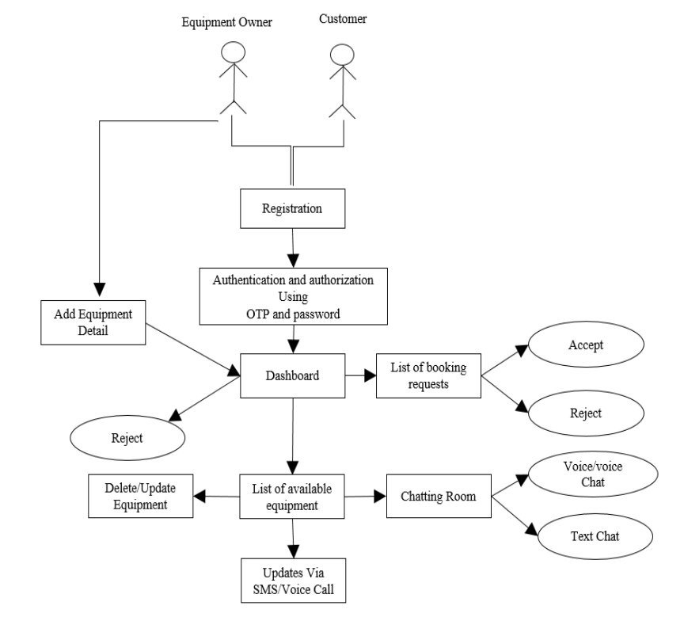

8

# CHAPTER 4: DIAGRAM

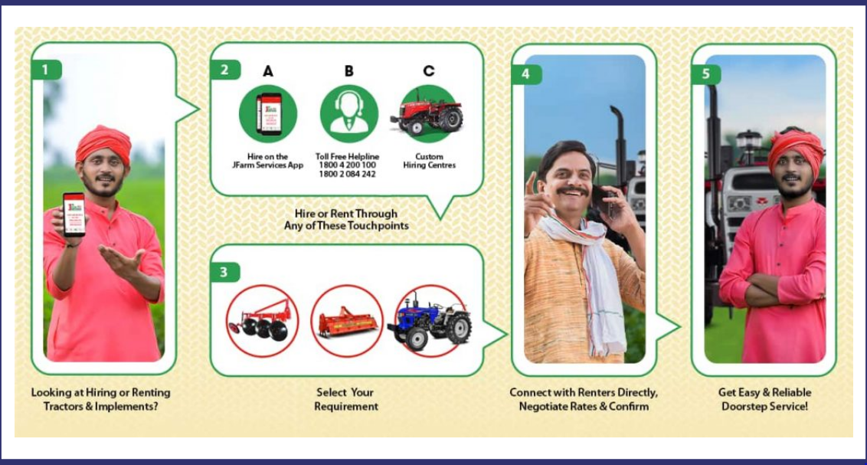

Fig.4.1: Working model

9

# CHAPTER 5 CONCLUSION

The Affordable Farm Equipment Sharing Platform represents a transformative solution to address the challenges faced by small-scale farmers in accessing agricultural machinery. Through stakeholder engagement, research-driven design, and iterative development, the platform has been designed to meet the specific needs of farmers while promoting collaboration, efficiency, and sustainability in agriculture. By democratizing access to farm equipment, the platform empowers farmers to overcome financial barriers, improve productivity, and adopt sustainable farming practices. Moving forward, continuous monitoring, evaluation, and iteration will be key to ensuring the platform's effectiveness and relevance in supporting the needs of small-scale farmers and contributing to rural development. With its potential to enhance livelihoods, promote resource efficiency, and foster community resilience, the Affordable Farm Equipment Sharing Platform stands as a testament to the power of innovation in addressing pressing challenges in agriculture.

10

**REFERENCES**

* Smith, J., & Brown, A. (Year). "Empowering Small-scale Farmers: A Case Study of Affordable Farm Equipment Sharing Platforms." Journal of Agricultural Innovation, vol. 10, no. 2, pp. 123-135.
* Garcia, L., & Nguyen, T. (Year). "Community Building Through Affordable Farm Equipment Sharing: A Social Impact Analysis." International Journal of Rural Development, vol. 15, no. 4, pp. 367-378.
* Martinez, K., & Lee, S. (Year). "Economic Viability of Affordable Farm Equipment Sharing Platforms: A Comparative Analysis." Agricultural Economics Review, vol. 22, no. 3, pp. 289-302.
* Wang, Q., & Chen, H. (Year). "Overcoming Challenges in Implementing Farm Equipment Sharing Platforms: Insights from a Pilot Study." Journal of Agricultural Engineering Research, vol. 45, no. 1, pp. 56-68.
* Anderson, P., et al. (Year). "Collaborative Consumption and Sustainable Agriculture: Exploring the Environmental Impacts of Affordable Farm Equipment Sharing Platforms." Sustainability Science, vol. 12, no. 5, pp. 789-802.
* FAO (1985) ‘Multiform use of agricultural machinery’, Food and Agriculture Organization of the United Nations.
* Feder, G. and Slade, R. (1984) ‘The acquisition of information and the adoption of new technology.’ American Journal of Agricultural Economics, 66(3), pp. 312–320.
* IRRL (1986) ‘Small farm equipment for developing countries’, in The International Conference on Small Farm Equipment for Developing Counties: Past Experiences and Future Priorities.
* Seung-Yeoub Shin, Chang-Ho Kang, Seok-Cheol Yu, Byounggap Kim, Yu-Yong Kim, Jin-Oh Kim, Kyou-Seung Lee, Web-based Agricultural Machinery Rental Business Management System National Academy of Agricultural Science, Rural Development Administration, Jeonju, Korea, October 6th, 2014.
* Al-shihabi, S.T.; AIDurgam, M.M. A max–min ant system for the finance-based scheduling problem. Comput. Ind. Eng. 2017, 110, 264–276. [CrossRef].

11

* Krunal Bagaitkar1, Khoshant Lande. 2019. ‘Tractor Hiring Application for Farmers’. Department of Information Technology, S.B Jain Institute of Technology, Management and Research, Nagpur Project Guide, Department of Information and Technology, S.B Jain Institute of Technology, Management and Research, Nagpur.
* Seung-Yeoub Shin, Chang-Ho Kang. 2014. ‘Web-based Agricultural Machinery Rental Business Management System’. National Academy of Agricultural Science Korea Department of Bio-Mechatronic Engineering, Sungkyunkwan University, Suwon, Korea.
* S. Y. Jung. Study on the web-based maintenance and management system of small-scale public research facilities. Chonnam National University, Department of Architectural Engineering;2011. MS thesis.
* Small-scale actors in agri-food value chains the services of agricultural mechanization hire enterprises.” Martin Hilmi Volume: 07 Issue: 04 | Oct.-Dec. | 2018.
* Julius, A. (2014) ‘Factors limiting small-scale farmers’ access and use of tractors for agricultural mechanization in Abuja, north central zone, Nigeria’, European Journal of Sustainable Development, 3(1), pp. 115–124

12